Experiment 8.1
Determination and Plotting of Magnetic Field Intensity vs Distance

Code File Name: Exp8_1_MagneticFieldIntensity.m
Code
clc;
clear;
I = input('Enter the current (A):');
r = input('Enter the distance (m):');
mu0 = 4*pi*1e-7;
H = I/(2*pi*r);
disp('Magnetic Field Intensity is');
disp(H);
% Plot
x = linspace(0.1,10,100);
H_plot = I./(2*pi*x);
figure;
plot(x,H_plot,'LineWidth',2);
xlabel('Distance (m)');
ylabel('Magnetic Field Intensity (A/m)');
title('Magnetic Field Intensity vs Distance');
Command Prompt
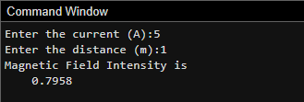
Enter the current (A):5
Enter the distance (m):1
Magnetic Field Intensity is
0.7958

Output Graph
